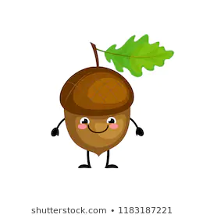
Take-Away Task Autumn 2020

As we are focusing on the UK and the local area for our Topic this half term, we would like you to do one of the following activities:

- Go for a walk with your grown-ups and take photographs of anything interesting you come across in your local area.
  - Put these pictures into a power-point or make a scrap book and write about the photos.

- Write a poem about your local area-
  - This could be about the beach, the woods, the downs, your local village, a park etc.

- Research a city in the UK –
  - Tell us what you have learnt about the city i.e. population (how many people live there), historical facts, where in the UK it is, any famous people that live there/come from there etc?
  - Use this information to create a leaflet, poster or power-point, including images.

