TAKE AWAY TASK
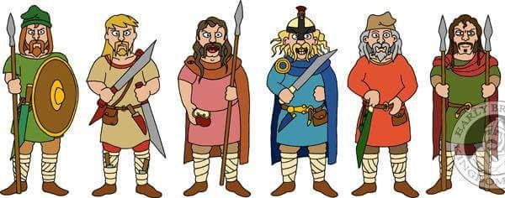
SUMMER TERM 2020

Our topic this term is the Anglo-Saxons.

Over the next few weeks, I would like you to come up with a piece of work which focuses on the Anglo-Saxons.

You might like to:
- Make an information leaflet about one aspect of Anglo-Saxon life i.e. Food, Homes, Battles.
- Make a wanted poster about an Anglo-Saxon person
- Write a story or diary entry about Anglo-Saxon life.
- Create some Anglo-Saxon art using the Anglo-Saxon runes.
These are some links to get more information about the Anglo-Saxons.

Including links to some artefacts found at an Anglo-Saxon burial site!

http://primaryhomeworkhelp.co.uk/saxons.htm

https://www.bbc.co.uk/history/british/launch_tl_british.shtml

https://www.ancient-origins.net/news-history-archaeology/anglo-saxon-cemetery-full-grave-goods-discovered-near-prehistoric-henge-020812

https://artsandculture.google.com/search?q=sutton%20hoo

http://futhorc.com/futhorc/runic.php (to create your own rune)

Suggest reading:
Beowulf by Michael Morpurgo (2006)
How to train your Dragon by Cressida Cowell (2003)
Horrible Histories Smashing Saxons. (2000)
