History Knowledge Organiser – Year 3/4 - Anglo-Saxons

Key Words | Definition
Settlement | A community of people smaller than a town
Community | The people living in an are
Pagan | If you don’t believe in a religion or if you worship more than one God.
Converted | To change to a new religion
Trade | The buying and selling of goods
Archaeologist | Someone who studies the buildings, graves, tools and other object of people who lived in the past.
Burial site | The land used for burying dead people.
Self-sufficient | Able to provide for your own needs without the help of others.
Craftsman | A skilled who practices some trade or handicraft.
Hill fort | An area on a hilltop enclosed by a system of defencing banks and ditches.
Dispute | An argument or disagreement.
Meted out | To give or order a punishment
Who were the Anglo-Saxons? The Anglo-Saxon period in Britain was between 410-1066AD. It was a time of war, the breaking up of Roman Britain into the separate kingdoms, of religious conversion and after the 790s continual battle against the Vikings.

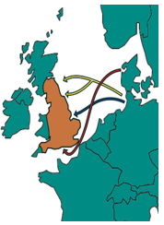

Key dates
410AD | The last Roman soldiers were ordered to leave England.
500AD | The invaders were resisted fiercely by the Romans who might have been led by King Arthur.
650AD | Seven separate kingdoms formed.
850AD | The seven kingdoms had been consolidated into three large Anglo-Saxon kingdoms: Northumbria, Mercia, and Wessex. The Anglo-Saxons became Christians.
1066AD | Battle of Hastings.

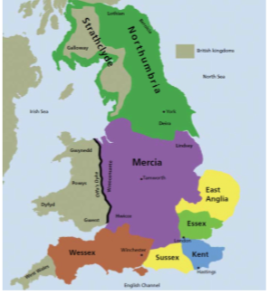
Invasion and settlement
Anglo-Saxons in Britain went from invaders to settlers. Originally from Germany and Scandinavia, the Angles, Saxons and Jutes were lots of warring tribes who settled in Britain 410AD.
With Picts and Scots attacking from the north, the Briton’s invited the Anglo-Saxon to help defend them. Eventually they took over.
Many Anglo-Saxon’s came peacefully to find land to farm. Their homelands in Scandinavia often flooded so it was tough to grow food there.
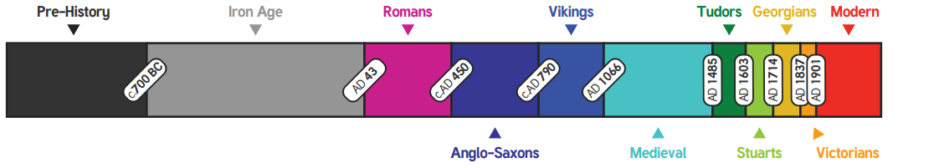
Whole families set sail across the sea to live in Britain. They brought tools, weapons and farm animals with them and built villages with new homes.

