Slindon Church of England Primary School
PE and Sports Premium Plan
2020/2021

Slindon Church of England Primary School- Sports Premium
Total number of eligible pupils on roll | 60
Lump sum | £16,000
Amount received per pupil (£10 per pupil) | £600
Actual amount received | £16, 600
Amount carried from last year | £12,527.63
Total amount available to spend 2020/21 | £29,127.63
Forecasted expenditure 2020/21 | 29,000
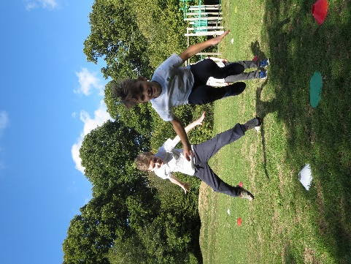
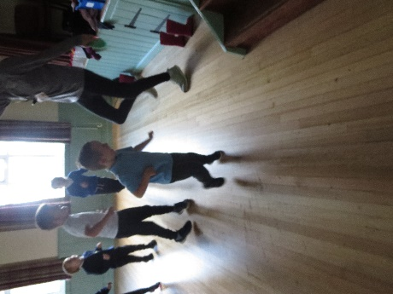

Key achievements to date | Areas of further improvement and baseline evidence of need
- Additional swimming so that all children in Years 1-5 participate in weekly swimming for two terms. Children in Reception in Reception and Year 6 participate in swimming for one term.  - Continuous Professional Development for staff through engagement of West Sussex West School Sport Partnership (WSW SSP).  - All children (both KS1 and KS2) compete in sporting festivals and competitions. | - To provide a wider variety of clubs to entice specific children, including those eligible for the PPG, to participate in a sports club.  - To increase parent participation in sporting events/ achievement: celebrate via school newsletters and school website.
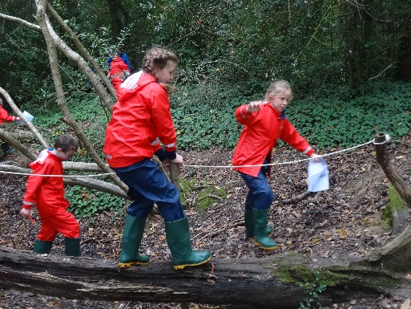
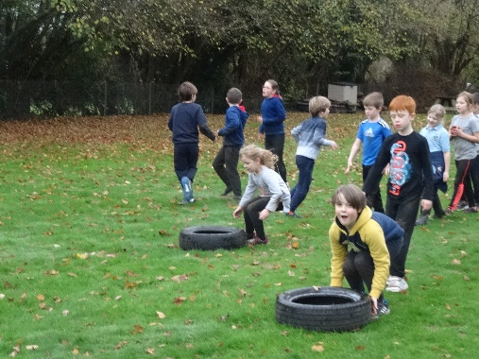
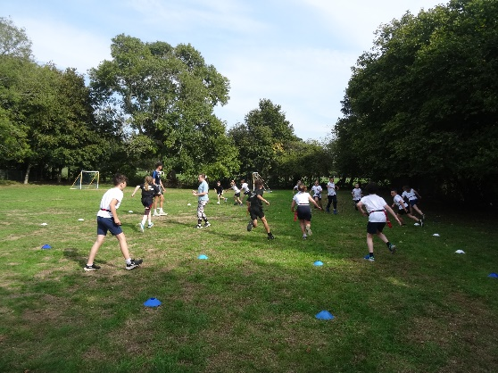
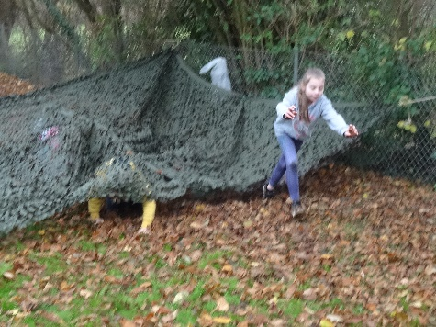
Key Indicators
Key Indicator 1: The engagement of all pupils in regular physical activity – Chief Medical Officer guidelines recommend that primary school pupils undertake at least 30 minutes of physical activity a day in school
Key Indicator 2: The profile of PE and Sports being raised across the school as a tool for whole school improvement
Key Indicator 3: Increased confidence, knowledge and skills of all staff in teaching PE and sport
Key Indicator 4: Broader experience of a range of sports and activities offered to all pupils
Key Indicator 5: Increased participation in competitive sport

Academic Year: 2020/21 | Total fund allocated: £16,600 | Date: April 2020
Membership to and engagement with West Sussex West School Sport Partnership (WSW SSP) |  |  |  | Percentage of total allocation:
 |  |  |  | %
Intent | Implementation |  | Impact | 17%
Your school focus should be clear what you want the pupils to know and be able to do and about what they need to learn and to  consolidate through practice: | Make sure your actions to achieve are linked to your intentions: | Funding allocated: | Evidence of impact: what do pupils now know and what can they now do? What has changed?: | Sustainability and suggested next steps:
Continue to increase staff confidence, knowledge and skills in teaching PE and sport through CPD opportunities within the WSW SSP. | - Teachers can access high quality specific CPD courses throughout the academic year delivered by PE specialists.  - Access to West Sussex Primary PE conference, which covers both practical and theory CPD. | £1,980 for membership | Engagement with CPD, greater effectiveness in delivery of sports and PE curriculum  KI 2, KI 3 | .
For our children to continue to increase their participation in competitive sport | - Children from KS1 and KS2 will have the opportunity to compete and represent the school in a variety of sports. These will be a mix of both competition and festival based activities to help cater for all children. | £3,000 | Impact of competitive experiences with children beyond our school has impacted on the values seen in the children participating, such as resilience, passion, kindness, self-control.  KI 1, KI 2, KI 4, KI 5
Employ a sports specialist to work across school enriching PE and enhancing regular physical activity at break and lunch times |  |  |  | Percentage of total allocation:
 |  |  |  | %
Intent | Implementation |  | Impact | 17%
Your school focus should be clear what you want the pupils to know and be able to do and about what they need to learn and to  consolidate through practice: | Make sure your actions to achieve are linked to your intentions: | Funding allocated: | Evidence of impact: what do pupils now know and what can they now do? What has changed?: | Sustainability and suggested next steps:
Sports specialist to plan and lead delivery of PE across the school, raising the standard of delivery and sharing best practice. | Improve the skills of staff and pupils by working with and alongside sports specialist.  Vary the PE and sports experiences offered to the children throughout the year. | £5,000 | Increased confidence, knowledge and skill set of staff.  Varied opportunities and experiences for children.
Raise the profile of sports and outdoor learning throughout the school community. | Sports specialist to engage with external agencies including The Mayne Trainer programme and Commando Joes, and engage with parents/ carers to share |  | Parents/ carers engage with sports and PE celebrations and opportunities.  Profile of sports and PE is raised within the school.
Implement the Commando Joes Character Education Programme, to develop active learning outside and character education. |  |  |  | Percentage of total allocation:
 |  |  |  | %
Intent | Implementation |  | Impact | 14%
Your school focus should be clear what you want the pupils to know and be able to do and about what they need to learn and to  consolidate through practice: | Make sure your actions to achieve are linked to your intentions: | Funding allocated: | Evidence of impact: what do pupils now know and what can they now do? What has changed?: | Sustainability and suggested next steps:
Establish and implement the Commando Joe Character Education programme across the school to enrich the school’s curriculum and enhance opportunities for learning outside. | INSET day training for all staff, led by Commando Joe veteran.  Classes to map programme with curriculum planning to develop and deliver opportunities for enrichment. | £1,170 | Children engage with meaningful learning opportunities that match curriculum intent and support and broaden their active learning experiences.
Employ additional staff to support the opportunities for learning outside, alongside and independent of the Commando Joe programme. | Timetabled opportunities for extra staff to enable and enhance opportunities to learn outside. | £2,750 | Staff facilitate learning opportunities that match curriculum intent and support and broaden their active learning experiences.
To introduce a weekly (veteran led) outdoor activity programme ‘The Mayne Trainer’ to children in lower Key Stage 2, to enhance outdoor learning/ teambuilding/ sporting opportunities, broadening activities for all pupils. |  |  |  | Percentage of total allocation:
 |  |  |  | %
Intent | Implementation |  | Impact | 15%
Your school focus should be clear what you want the pupils to know and be able to do and about what they need to learn and to  consolidate through practice: | Make sure your actions to achieve are linked to your intentions: | Funding allocated: | Evidence of impact: what do pupils now know and what can they now do? What has changed?: | Sustainability and suggested next steps:
For children to experience further opportunities to develop character through sporting and outdoor activities. | Children in Acorn Class (lower Key Stage 2) to complete year long programme every Friday morning, supporting the development of the schools’ values. | £4,500 | Children engage with meaningful sporting and active outdoor learning opportunities that match curriculum intent, broadening their active learning experiences.
Ensure that the school grounds safely facilitate PE, sports and outdoor learning opportunities. |  |  |  | Percentage of total allocation:
 |  |  |  | %
Intent | Implementation |  | Impact | 4%
Your school focus should be clear what you want the pupils to know and be able to do and about what they need to learn and to  consolidate through practice: | Make sure your actions to achieve are linked to your intentions: | Funding allocated: | Evidence of impact: what do pupils now know and what can they now do? What has changed?: | Sustainability and suggested next steps:
Ensure statutory contracts and health and safely guidance is adhered to in ensuring the maintenance of the grounds to safely engage with sports, PE and outdoor learning. | Grounds work routinely checked and maintained. Purchase of external contracts such as tree surgeon to maintain grounds and safety. | £1,000 | Sports, PE and outdoor learning opportunities can take place safely.
Repair and develop the EYFS/ KS1 outdoor area to enable children are able to safely engage in regular physical activity and play. |  |  |  | Percentage of total allocation:
 |  |  |  | %
Intent | Implementation |  | Impact | 33%
Your school focus should be clear what you want the pupils to know and be able to do and about what they need to learn and to  consolidate through practice: | Make sure your actions to achieve are linked to your intentions: | Funding allocated: | Evidence of impact: what do pupils now know and what can they now do? What has changed?: | Sustainability and suggested next steps:
Enable all children in EYFS and Key Stage 1 to be able to engage in regular physical activity in an area that is safe and meets and supports their developmental needs. | Make safe the rotting wood and ensure that the children have direct access to an outdoor space for physical play and exercise. | £9,500 | Children safely engage in regular physical exercise and broaden their experiences in outdoor play opportunities.

