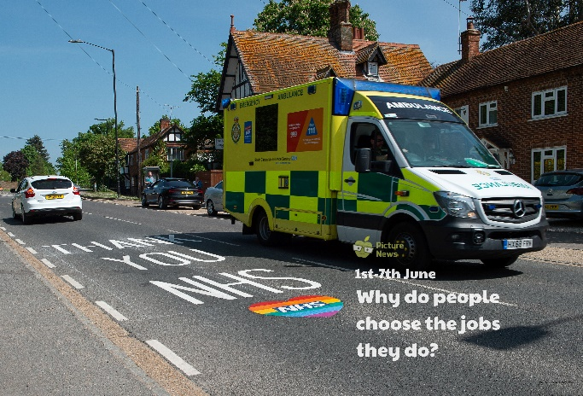

Imagine your job is a fitness instructor! Design a fitness class and challenge your family to take part in it!

Some people wear a uniform to work. Discuss some of the reasons a uniform is worn e.g. the uniform protects them, we recognise who they are, it shows they belong to that job/group. Design a uniform for a job of your choice.

Give yourself 1 minute to list as many jobs as you can think of. Now ask someone else in your home to do it but they can’t use any of the ones you’ve already listed!

Think about how jobs and roles have changed over time. Can you research what jobs people did 50 years ago, 100 years ago? How are they the same/different?

Sometimes we describe some of the things that need doing as jobs e.g. tidying, washing up, being a playground buddy at school. Create a list of jobs you could complete at home and at school. Ask someone at home or school if you can do the jobs. Tick them off once they are done!

Jot down what you enjoy, what are you good at, what you don’t enjoy, jobs you think you might like to do, jobs you think you would not like to do. There is plenty of time to decide what you might like to do when you grow up but thinking about these things might help you.

Most people earn money for doing their job. Different jobs pay different amounts of money. Look at some of the different coins and notes we use and say what each is worth. Create a wish list of things you would like to save up for and buy. What notes and coins would you need to pay for each item exactly? Would you get change from £100? How much?

**Learning from Home**

Use the ideas below, alongside this week’s resource, to support your home learning.