4th May 2020 – English
Hello Acorns,
This is an extract from a book. Below there are some activities and questions to complete about this extract.
if you need any help with this – please email the office and they can let me know.
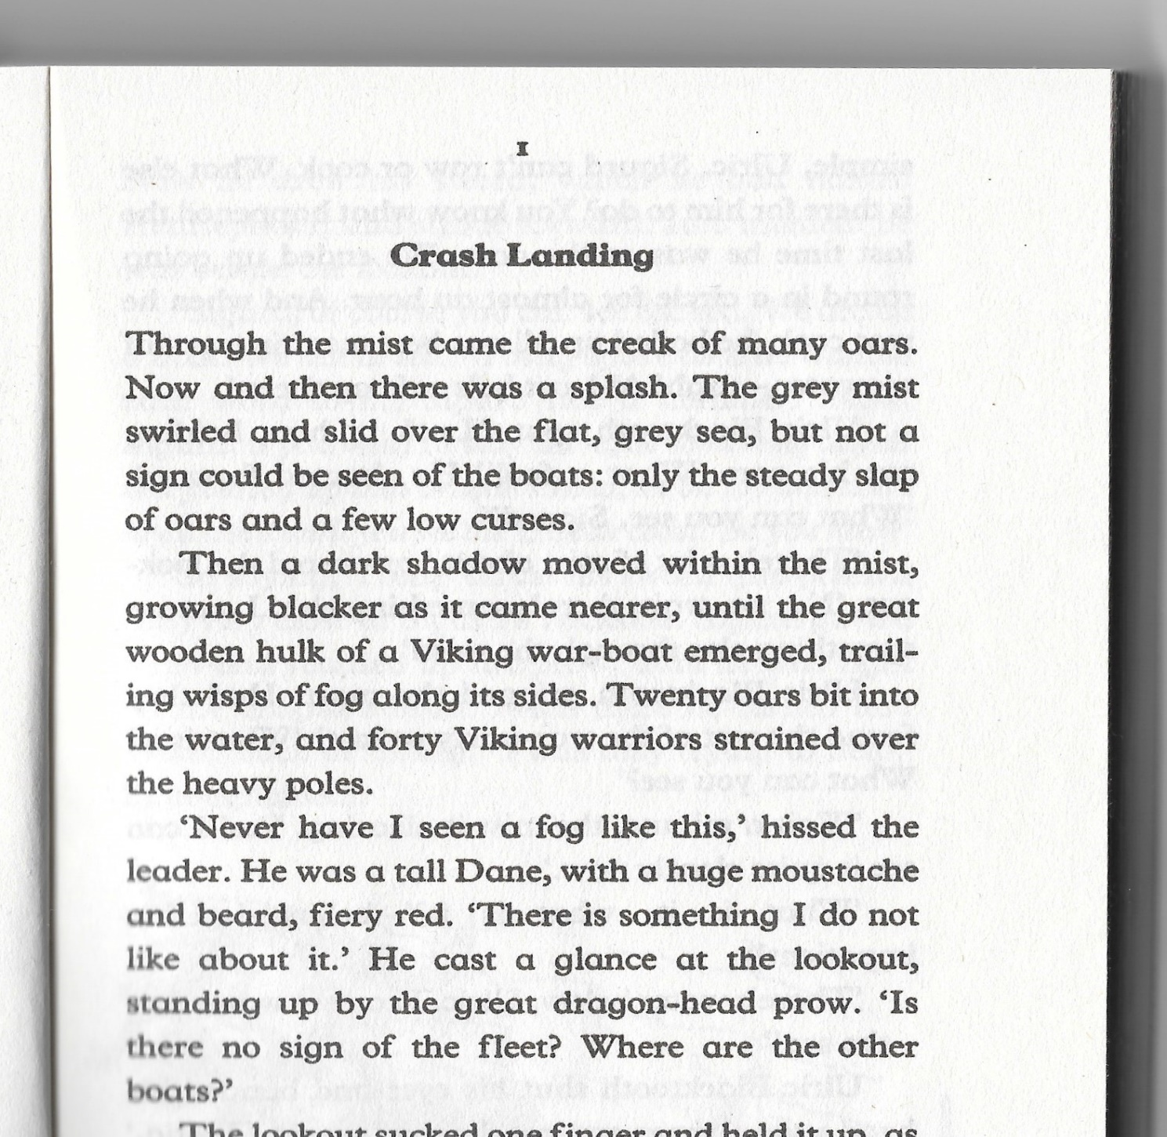
Miss Heater
1 – Highlight all the adjectives in the text.
- Remember: Adjectives describe nouns to tell you more about something (i.e. the tall, dark tree)

2 – Can you find the use of personification in the text?
- Personification is a way to give human characteristics to a thing – an idea or an animal. Such as ‘The wind whispered through the dry grass’ or ‘the fire swallowed the forest’

3- How does the opening paragraph make you feel?
- Look at the words used – are they happy and positive words?
- What can you imagine when reading it – for example, does it bring excitement or fear?

4 – Write your own story about what will happen next?

5 – Draw a picture of the character described in the book and write a few sentences about who you think they are and what they are like.

